

CIA-3

Subject: R Programming (STA102-2)
Name: Alister Luke Lewis
Class: 2BScDS
Reg No: 2541403
Submitted To: Prof. Divya V R

Statistical Analysis of Movie Performance
Alister Luke Lewis
2026-03-01
Mini Project
#Statistical Analysis of Movie Performance Using R Programming
#1. Introduction:
The Entertainment and Media industry is one of the fastest-growing industries worldwide, driven by the surging popularity of digital media, movies, and streaming services. Movies have become an integral part of the Entertainment and Media industry, which influences the culture, earns huge revenues, and dictates the audience’s choice of movies. Due to the availability of large-scale movie datasets, statistical analysis has become a vital tool to comprehend the patterns of movie performance, such as the relationship between movie genre, rating, runtime, and gross revenue.
This project undertakes a statistical analysis of movie performance using various variables such as movie genre, rating, runtime, and gross revenue, to identify the trends and patterns that affect the performance of movies in the Entertainment and Media industry.
The programming language R is being utilized as the main tool for analysis because of its strong capabilities for statistical computing, data manipulation, as well as data visualization. R offers numerous built-in functions that make it an efficient tool for handling multivariate data, exploratory data analysis, as well as the creation of effective graphical representations of the data. Hence, it is an effective tool for carrying out the statistical analysis for the movie performance data.
#2. Dataset Description:
The dataset used for this study is the movie performance dataset, which was obtained from a secondary source of information (an IMDb-based dataset available on the Kaggle website). The source of the dataset is reliable, and the dataset is available on the publicly available data source called the Kaggle website, which offers publicly available datasets that may be used for research purposes.
The dataset used has more than 200 observations and various variables related to the characteristics of movies. For the purpose of this project, only the required variables were used that were necessary to perform the statistical analysis of the movie performance dataset, which helps to achieve the purpose of the assignment.
Six variables were chosen for the analysis based on their relevance to movie performance:
- Movie Title – Name of the movie
- main genre – Primary genre classification of the movie
- Year – Year in which the movie was released
- Runtime(Mins) – Total duration of the movie in minutes
- Rating – IMDb audience rating of the movie
- Total Gross – Total box office revenue earned by the movie
Type of Variables:
Categorical Variables:
- Movie Title
- main genre
Numerical Variables:
- Year
- Runtime(Mins)
- Rating
- Total Gross
#3. Objectives:
1.To import and preprocess the movie dataset in R to prepare it for statistical analysis.
2.To summarize the chosen variables using relevant descriptive statistical measures.
3.To investigate the distribution of the number of movies across various genres in the Entertainment and Media industry.
4.To investigate the relationship between movie ratings and gross revenue using bivariate analysis.
5.To investigate the ratings of the movies across genres using relevant graphical analysis.
6.To conduct multivariate data manipulation using relevant R functions and packages.
7.To visualize the key trends in the performance of the movies to help in the development of insights in the Entertainment and Media industry.

#4. Methodology:
#Importing, Reading and Preparing the Data.
# Reading the Excel file
library(readxl)
movies_data=read_excel("C:/Users/alist/Documents/Entertainement and Media.xlsx")
# Selecting the required variables (6 variables)
movies_data=movies_data[, c("Movie_Title",
"main_genre",
"Year",
"Runtime(Mins)",
"Rating",
"Total_Gross")]
movies_data
## # A tibble: 220 × 6
## Movie_Title main_genre Year `Runtime(Mins)` Rating Total_Gross
## <chr> <chr> <dbl> <dbl> <dbl> <chr>
## 1 The Dark Knight Action 2008 152 9 $534.86M
## 2 The Lord of the Rings: T… Action 2003 201 9 $377.85M
## 3 Inception Action 2010 148 8.8 $292.58M
## 4 The Lord of the Rings: T… Action 2002 179 8.8 $342.55M
## 5 The Lord of the Rings: T… Action 2001 178 8.8 $315.54M
## 6 The Matrix Action 1999 136 8.7 $171.48M
## 7 The Empire Strikes Back Action 1980 124 8.7 $290.48M
## 8 Terminator 2: Judgment D… Action 1991 137 8.6 $204.84M
## 9 Star Wars Action 1977 121 8.6 $322.74M
## 10 Shichinin no samurai Action 1954 207 8.6 $0.27M
## # ℹ 210 more rows
# Cleaning Total_Gross (remove $ and M and convert to numeric)
movies_data$Total_Gross=gsub("\\$", "", movies_data$Total_Gross)
movies_data$Total_Gross=gsub("M", "", movies_data$Total_Gross)
movies_data$Total_Gross=as.numeric(movies_data$Total_Gross)
# Display first few records
head(movies_data)
## # A tibble: 6 × 6
## Movie_Title main_genre Year `Runtime(Mins)` Rating Total_Gross
## <chr> <chr> <dbl> <dbl> <dbl> <dbl>
## 1 The Dark Knight Action 2008 152 9 535.
## 2 The Lord of the Rings: Th… Action 2003 201 9 378.
## 3 Inception Action 2010 148 8.8 293.
## 4 The Lord of the Rings: Th… Action 2002 179 8.8 343.
## 5 The Lord of the Rings: Th… Action 2001 178 8.8 316.
## 6 The Matrix Action 1999 136 8.7 171.
# Display last few records
tail(movies_data)
## # A tibble: 6 × 6
## Movie_Title main_genre Year `Runtime(Mins)` Rating Total_Gross
## <chr> <chr> <dbl> <dbl> <dbl> <dbl>
## 1 Spider-Man 2 Action 2004 127 7.4 374.
## 2 Open Range Action 2003 139 7.4 58.3
## 3 Master and Commander: The… Action 2003 138 7.4 93.9
## 4 X2 Action 2003 134 7.4 215.
## 5 Spider-Man Action 2002 121 7.4 404.
## 6 The Rock Action 1996 136 7.4 134.
# Total number of rows
nrow(movies_data)
## [1] 220
# Total number of columns
ncol(movies_data)
## [1] 6
# Examine structure of the dataset
str(movies_data)
## tibble [220 × 6] (S3: tbl_df/tbl/data.frame)
## $ Movie_Title : chr [1:220] "The Dark Knight" "The Lord of the Rings: The Return of the King" "Inception" "The Lord of the Rings: The Two Towers" ...
## $ main_genre : chr [1:220] "Action" "Action" "Action" "Action" ...
## $ Year : num [1:220] 2008 2003 2010 2002 2001 ...
## $ Runtime(Mins): num [1:220] 152 201 148 179 178 136 124 137 121 207 ...
## $ Rating : num [1:220] 9 9 8.8 8.8 8.8 8.7 8.7 8.6 8.6 8.6 ...
## $ Total_Gross : num [1:220] 535 378 293 343 316 ...
# Check number of rows and columns
cat("\nDimensions of the dataset:\n")
##
## Dimensions of the dataset:
dim(movies_data)
## [1] 220 6
#Explaination of Data Preparation:
The dataset was imported into R using the read_excel() function from the readxl package.
Only the required six variables were selected from the original dataset for focused analysis.
The Total_Gross column was cleaned by removing the $ symbol using gsub().
The letter M was removed from Total_Gross to make the values numeric-ready.
The cleaned Total_Gross column was converted to numeric using as.numeric().
The head() function was used to view the first few rows of the dataset.
The tail() function was used to view the last few rows for verification.
The nrow() function was used to check the number or rows.
The ncol() function was used to check the number or columns.
The str() function was used to examine the structure and data types of the dataset.
The dim() function was used to check the number of rows and columns.

#Descriptive Statistics
#1. Frequency Distribution of Movie Genre
# Frequency table for main_genre
genre_table=table(movies_data$main_genre)
genre_table
##
## Action Animation
## 200 20
# Percentage distribution
genre_percent=prop.table(genre_table)*100
round(genre_percent, 2)
##
## Action Animation
## 90.91 9.09
# Bar plot
barplot(genre_table,
main="Frequency of Movie Genres",
xlab="Main Genre",
ylab="Number of Movies",
col="lightblue")
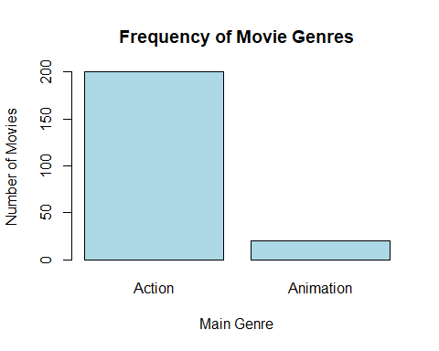

#Interpretation:
The frequency and percentage tables show how movies are distributed across different genres.
We can see that the number of Action movies are higher than the number of Animation movies The bar plot visually highlights the most common genre in the dataset.
#2. Descriptive Analysis of Movie Rating
# Summary statistics
mean_rating=mean(movies_data$Rating)
median_rating=median(movies_data$Rating)
sd_rating=sd(movies_data$Rating)
range(movies_data$Rating)
## [1] 7.4 9.0
cat("Mean Rating:",round(mean_rating,2),"\n")
## Mean Rating: 7.82
cat("Median Rating:",median_rating,"\n")
## Median Rating: 7.7
cat("Standard Deviation:",round(sd_rating,2),"\n")
## Standard Deviation: 0.35
# Histogram
hist(movies_data$Rating,
main="Distribution of Movie Ratings",
xlab="Rating",
col="lightgreen",
border="black")
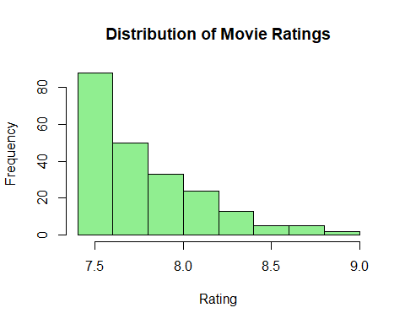
# Boxplot
boxplot(movies_data$Rating,
main="Boxplot of Movie Ratings",
col="orange")
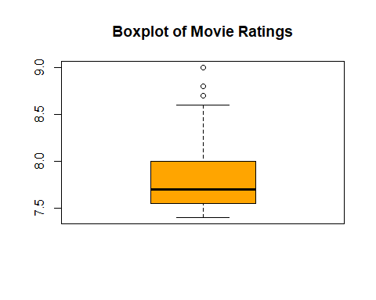
#Interpretation:
The descriptive analysis of movie ratings shows that the average rating is 7.82.
The median rating is 7.7, which represents the midpoint of the ratings distribution.
The standard deviation of 0.35 suggests that the variation in movie ratings is low, meaning that ratings are closely clustered around the mean.
The histogram indicates how ratings are distributed across movies. Most films appear to be concentrated around 7.5-7.7, suggesting that extremely high ratings are relatively fewer.
The boxplot provides additional insight into the spread and potential outliers. The visible outlier points indicate that a few movies have unusually high ratings compared to the majority.
Overall, the ratings distribution gives a clear picture of audience reception patterns in the
#3. Descriptive Analysis of Runtime
# Summary statistics
mean_runtime=mean(movies_data$`Runtime(Mins)`)
median_runtime=median(movies_data$`Runtime(Mins)`)
sd_runtime=sd(movies_data$`Runtime(Mins)`)
range(movies_data$`Runtime(Mins)`)
## [1] 76 213
cat("Mean Runtime:",round(mean_runtime,2),"\n")
## Mean Runtime: 126.08
cat("Median Runtime:",median_runtime,"\n")
## Median Runtime: 123.5
cat("Standard Deviation:",round(sd_runtime,2),"\n")
## Standard Deviation: 23.14
# Histogram
hist(movies_data$`Runtime(Mins)`,
main="Distribution of Runtime",
xlab="Runtime (Minutes)",
col="peachpuff",
border="black")
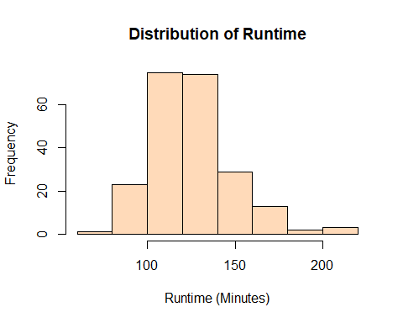
# Boxplot
boxplot(movies_data$`Runtime(Mins)`,
main="Boxplot of Runtime",
col="lightblue")
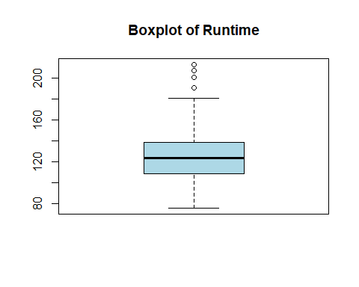
#Interpretation:
The descriptive analysis of movie runtime shows that the average runtime is 126.08 minutes.
The median runtime is 123.5 minutes, which represents the midpoint of the movie duration distribution.
The standard deviation of 23.14 suggests moderate variation in movie lengths, indicating that runtimes are moderately spread around the mean.
The histogram shows how movie durations are distributed, with most films concentrated around the common runtime range.
The boxplot provides additional insight into the spread and potential outliers.
The visible outlier points indicate that a few movies have unusually long durations compared to the majority, giving a clear picture of runtime patterns in the dataset.
#4. Descriptive Analysis of Total Gross
# Summary statistics
mean_gross=mean(movies_data$Total_Gross)
median_gross=median(movies_data$Total_Gross)
sd_gross=sd(movies_data$Total_Gross)
range(movies_data$Total_Gross)
## [1] 0.01 936.66
cat("Mean Total Gross:",round(mean_gross,2),"\n")
## Mean Total Gross: 140.67
cat("Median Total Gross:",median_gross,"\n")
## Median Total Gross: 78.41
cat("Standard Deviation:",round(sd_gross,2),"\n")
## Standard Deviation: 165.9
# Histogram
hist(movies_data$Total_Gross,
main="Distribution of Total Gross",
xlab="Total Gross (Millions)",
col="lightyellow",
border="black")
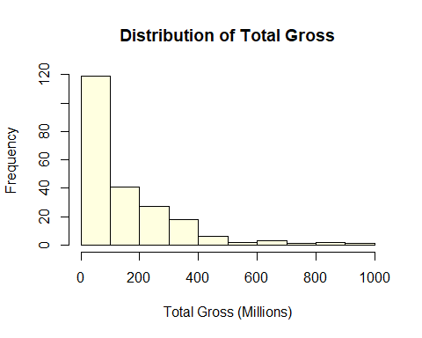
# Boxplot
boxplot(movies_data$Total_Gross,
main="Boxplot of Total Gross",
col="lightgreen")
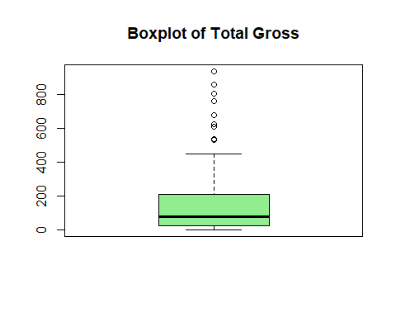
#Interpretation:
The descriptive analysis of total gross revenue shows that the average gross is 140.67 million.
The median gross is 78.41 million, representing the midpoint of the earnings distribution.
The standard deviation of 165.9 indicates high variation in movie earnings, suggesting that revenues are widely spread around the mean.
The histogram shows how box office earnings are distributed, typically with most movies earning in the lower to mid revenue range.
The boxplot provides further insight into spread and outliers.
The visible outlier points indicate that a few movies earned exceptionally high revenue compared to the majority, highlighting the presence of blockbuster films in the dataset.

#Bivariate Analysis:
#1. Rating vs Total Gross
# Correlation between Rating and Total_Gross
cor_rating_gross=cor(movies_data$Rating,
movies_data$Total_Gross)
cat("Correlation between Rating and Total Gross:",round(cor_rating_gross,3),"\n")
## Correlation between Rating and Total Gross: 0.225
# Scatter plot
plot(movies_data$Rating,
movies_data$Total_Gross,
main="Rating vs Total Gross",
xlab="Movie Rating",
ylab="Total Gross (Millions)",
col="blue",
pch=19)
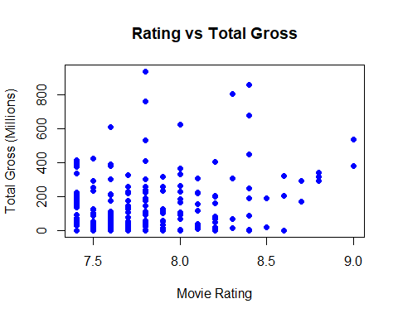
#Interpretation:
The correlation between movie rating and total gross is 0.225, indicating a weak positive relationship.
This suggests that higher-rated movies tend to earn slightly higher revenue, but the relationship is not very strong.
The scatterplot shows no strong or clear trend between IMDb ratings and box office earnings.
High-rated movies (8.5–9.0) often have low gross earnings, while some movies with good ratings (around 8.0–8.5) earn very high amounts (600–800 million).
This suggests that higher IMDb ratings do not guarantee higher commercial success.
#2. Runtime vs Total Gross
# Correlation
cor_runtime_gross=cor(movies_data$`Runtime(Mins)`,movies_data$Total_Gross)
cat("Correlation between Runtime and Total Gross:",round(cor_runtime_gross,3),"\n")
## Correlation between Runtime and Total Gross: 0.297
# Scatter plot
plot(movies_data$`Runtime(Mins)`,
movies_data$Total_Gross,
main="Runtime vs Total Gross",
xlab="Runtime (Minutes)",
ylab="Total Gross (Millions)",
col="darkgreen",
pch=19)
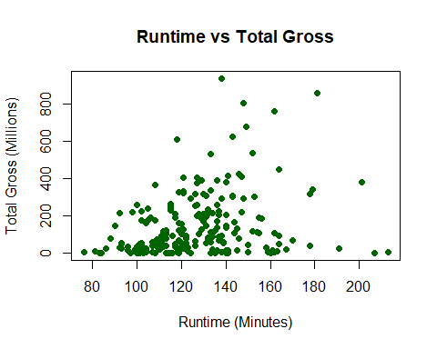
#Interpretation:
The correlation between runtime and total gross is 0.297, which indicates a weak to moderate positive relationship.
This implies that longer movies tend to generate somewhat higher box office revenue, although the association is not very strong.
The scatterplot shows no strong or clear trend between movie runtime and box office earnings.
Most movies with runtimes between 100–160 minutes have gross earnings ranging from very low (near 0) to moderate (200–400 million), with a dense cluster in this range.
A few longer movies (160–200 minutes) and some shorter ones achieve very high gross (600–800 million+), but these are outliers.
This suggests that longer runtime does not guarantee higher commercial success, and box office performance depends more on other factors such as genre, marketing, or franchise popularity rather than movie length alone.
#3. Rating across Genres
# Boxplot: Rating by Genre
boxplot(Rating~main_genre,
data= movies_data,
main="Movie Ratings across Genres",
xlab="Genre",
ylab="Rating",
col="lightblue")
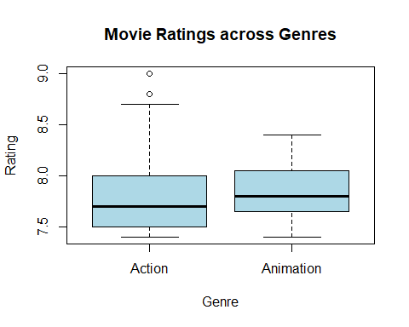

#Interpretation:
Both genres have similar median ratings (around 7.7–7.8), showing no major difference in central tendency.
Action movies show a wider spread and more variability in ratings, with several outliers above 8.8–9.0.
Animation movies have a slightly narrower range and fewer extreme high ratings, but their median is comparable to Action.
Overall, Action and Animation movies in this dataset have very similar average ratings, with Action showing a bit more variation

#Multivariate Analysis:
#1. Using tapply() to find mean
# Mean Rating by Genre using tapply
tapply(movies_data$Rating,
movies_data$main_genre,
mean)
## Action Animation
## 7.8115 7.8550
# Mean Gross by Genre using tapply
tapply(movies_data$Total_Gross,
movies_data$main_genre,
mean)
## Action Animation
## 142.3856 123.5625
#Interpretation:
tapply() function is used for applying functions to subsets of a vector based on a factor
Here we can compare the mean values between Action and Animation based on Rating and Gross value
#2. Using dplyr Top 10 Highest Grossing Movies
# Loading the library
library(dplyr)
##
## Attaching package: 'dplyr'
## The following objects are masked from 'package:stats':
##
## filter, lag
## The following objects are masked from 'package:base':
##
## intersect, setdiff, setequal, union
# Top 10 Highest
top_movies=movies_data %>%
arrange(desc(Total_Gross)) %>%
select(Movie_Title,main_genre,Rating,Total_Gross) %>%
slice(1:10)
top_movies
## # A tibble: 10 × 4
## Movie_Title main_genre Rating Total_Gross
## <chr> <chr> <dbl> <dbl>
## 1 Star Wars: Episode VII - The Force Awakens Action 7.8 937.
## 2 Avengers: Endgame Action 8.4 858.
## 3 Spider-Man: No Way Home Action 8.3 805.
## 4 Avatar Action 7.8 761.
## 5 Avengers: Infinity War Action 8.4 679.
## 6 The Avengers Action 8 623.
## 7 Incredibles 2 Animation 7.6 609.
## 8 The Dark Knight Action 9 535.
## 9 Rogue One Action 7.8 532.
## 10 The Dark Knight Rises Action 8.4 448.
#Interpretation:
The table shows the top 10 highest grossing movies along with their genres and ratings.
It is evident that the Action genre dominates the list, with 9 out of the 10 movies belonging to Action.
Among all movies, Star Wars: Episode VII – The Force Awakens has the highest total gross, indicating exceptional commercial success.
However, the movie with the highest rating in the list is The Dark Knight (9.0), showing that the highest-earning movie is not necessarily the highest-rated.
#3. Using ggplot2 Density Plot
library(ggplot2)
ggplot(movies_data, aes(x = Total_Gross)) +
geom_density(fill = "orange") +
ggtitle("Density Plot of Total Gross") +
xlab("Total Gross") +
ylab("Density")
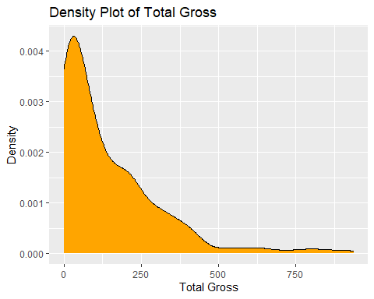
#Interpretation:
The curve has a high peak near 0, indicating that most movies in the dataset have low or very low box office earnings.
The distribution is heavily right-skewed, meaning a small number of movies earn very high amounts, while the majority earn much less.
The density drops sharply after ~250 million and becomes very flat beyond 500 million.
#4. t-test Short vs Long Movies
# Create runtime groups
movies_data$Length_Group=ifelse(
movies_data$`Runtime(Mins)`<median(movies_data$`Runtime(Mins)`),
"Short", "Long")
# Perform t-test
t.test(Rating~Length_Group,data=movies_data)
##
## Welch Two Sample t-test
##
## data: Rating by Length_Group
## t = 3.3076, df = 187.65, p-value = 0.001128
## alternative hypothesis: true difference in means between group Long and group Short is not equal to 0
## 95 percent confidence interval:
## 0.06163795 0.24381660
## sample estimates:
## mean in group Long mean in group Short
## 7.891818 7.739091
#Interpretation:
The average rating of long movies (7.89) is higher than short movies (7.74).
The p-value=0.0011 (< 0.05) shows this difference is statistically significant.
The confidence interval (0.062 to 0.244) does not include 0, confirming a real difference.
#5. Chi-square Test Genre vs Runtime Category
# Contingency table
chi_table=table(movies_data$main_genre,
movies_data$`Runtime(Mins)`)
chi_table
##
## 76 81 83 84 86 88 90 92 93 96 97 98 99 100 101 102 103 104 105 106
## Action 0 1 0 1 0 1 1 1 3 2 1 0 2 4 4 5 1 3 2 1
## Animation 1 0 1 0 1 0 0 1 0 0 0 1 0 2 1 2 1 1 0 0
##
## 107 108 109 110 111 112 113 114 115 116 117 118 119 120 121 122 123
## Action 3 4 4 2 3 4 7 0 4 2 3 1 7 4 6 3 2
## Animation 0 0 0 0 0 0 0 1 2 0 2 1 0 0 0 0 0
##
## 124 126 127 128 129 130 131 132 133 134 135 136 137 138 139 140 141
## Action 1 4 4 2 3 4 5 6 5 4 2 5 4 4 2 6 3
## Animation 1 0 0 0 0 0 0 0 0 1 0 0 0 0 0 0 0
##
## 143 144 145 146 147 148 149 150 152 153 154 155 156 158 159 160 161
## Action 3 2 2 2 2 2 1 2 2 1 1 2 1 1 1 1 1
## Animation 0 0 0 0 0 0 0 0 0 0 0 0 0 0 0 0 0
##
## 162 163 164 167 170 178 179 181 191 201 207 213
## Action 3 1 3 1 1 2 1 1 1 1 1 1
## Animation 0 0 0 0 0 0 0 0 0 0 0 0
# Chi-square test
chi_result=chisq.test(chi_table)
## Warning in chisq.test(chi_table): Chi-squared approximation may be incorrect
chi_result
##
## Pearson's Chi-squared test
##
## data: chi_table
## X-squared = 103.29, df = 82, p-value = 0.05611
#Interpretation:
The Chi-square test examines whether movie genre and runtime are associated.
The p-value is 0.056, which is slightly greater than 0.05.
Therefore, we fail to reject the null hypothesis at the 5% significance level.
This suggests there is no strong statistical association between genre and runtime in this data.
#5. Conclusion:
The analysis of the movie dataset provided valuable insights into the rating patterns, the distribution of the runtimes, and the box office success of the movies. From the analysis, it was evident that the ratings of the movies have low variability, while the gross earnings have high variability and skewness, indicating the existence of a few blockbuster movies in the dataset.
Moreover, the analysis revealed that the rating, runtime, and gross earnings have a low positive correlation with one another, indicating that the gross earnings have a mild relation to the rating and the runtime of the movies.
From the further analysis of the dataset using statistical tests, it was evident that the length of the movies has a mild relation to the ratings, while the genre and the length of the movies have no strong relation to one another. It is evident from the analysis that although some factors have mild correlations with the box office success of the movies, the success is determined by several factors.

